TiFund
TEACHER INVESTMENT FUND
PROJECT DOCUMENTATION
A web-based platform for teacher profiles, contributions, member services, and administration
Technical and user documentation
Prepared in October 2026
Report structure informed by the supplied project format and sample report

PRELIMINARY SECTION

Abstract
TiFund, the Teacher Investment Fund web application, provides a shared online space for teachers and administrators to manage member accounts, teacher profile information, contribution plans, payment records, public services, and contact requests. The project brings public information and protected account functions together in one responsive web application.
The system uses a React and Vite frontend and a PHP API. The API stores application records in SQLite through PDO. Google sign-in is used to identify accounts, while role-based routing separates the teacher dashboard from the administration dashboard. The system links each account to a teacher profile, checks for existing accounts during sign-in, and returns account details with the related teacher profile.
Members can review contribution history, manage non-Google profile fields, view notifications, and see their own contact submissions. Administrators can manage teacher accounts, plans, public content, notifications, payments, activity records, and all contact messages. The contact inbox groups messages by sender and supports read and unread status changes. Paystack payment verification is performed by the API, and the frontend uses only the public payment key.
The project follows an iterative software development approach based on the existing repository and the supplied project development guidance. Validation recorded for this documentation includes a successful production frontend build, PHP syntax checks, a SQLite ownership-migration smoke test, and a clean diff check. These checks confirm build and basic migration behaviour; they do not replace full user acceptance, payment-provider, or deployment testing.
The project provides an extensible foundation for member services and contribution administration. Safe operation depends on correct production configuration, suitable database backups, secure hosting, and additional end-to-end testing before live financial use.
Keywords: teacher investment fund, member profile, SQLite, contribution tracking, administration, contact inbox, web application

PRELIMINARY SECTION

Contents and abbreviations

Contents
Section
Abstract
Contents and abbreviations
Chapter One: Introduction
Chapter One: Scope and project value
Chapter Two: Literature and technology review
Chapter Two: Related technologies and design gap
Chapter Three: Methodology and requirements
Chapter Three: System architecture and roles
Chapter Three: Database design and data flow
Chapter Three: Process design, privacy, and validation
Chapter Four: System implementation
Chapter Four: User guide
Chapter Four: Installation and API reference
Chapter Four: Testing and results
Chapter Five: Discussion and conclusion
Chapter Five: Recommendations and conclusion
References and supporting information

List of figures
- Figure 1. TiFund system architecture
- Figure 2. TiFund database relationships
- Figure 3. TiFund contact and payment request flows

List of tables
- Table 1. Project objectives and outcomes
- Table 2. Functional and quality requirements
- Table 3. Main data entities
- Table 4. User roles and access
- Table 5. Validation results

Abbreviations
Term | Meaning
API | Application Programming Interface
CSS | Cascading Style Sheets
CRUD | Create, Read, Update, Delete
DB | Database
DFD | Data Flow Diagram
ERD | Entity Relationship Diagram
OAuth | Open Authorization
PDO | PHP Data Objects
UI | User Interface
URL | Uniform Resource Locator

CHAPTER ONE

Introduction

1.1 Background of the study
Teachers and member-based organisations need clear ways to keep member records, explain available services, receive enquiries, and review financial contributions. When these tasks are spread across paper forms, separate spreadsheets, and informal messages, staff may spend time locating information and members may not know where to find current account details.
TiFund is a web application designed for a teacher investment fund context in Ghana. It gives the public access to information about services and plans, and provides authenticated accounts for teachers and administrators. A connected API processes application requests and stores records in SQLite. The project combines profile management, member activity, plan display, payment records, contact messages, and administration tools.

1.2 Problem statement
A digital service can become difficult to operate when member data, payment history, service descriptions, and enquiries are handled in separate places. Without consistent account linking, staff may see incomplete profile information. Without access rules, a user may be shown records outside their account. Replacing a database without a migration plan can also leave older records behind. The project therefore needs a single, role-aware application with linked records, manageable content, and clear controls for its users.

1.3 Aim of the project
The aim is to develop and document a responsive web application that supports teacher account management, contribution information, member communication, and administration through a React frontend, PHP API, and SQLite database.

1.4 Project objectives
No. | Objective | Expected outcome
1 | Provide public information about the fund, services, plans, and contact options. | Visitors can browse current content and send enquiries.
2 | Provide secure, role-aware account access. | Teachers and administrators reach the correct dashboard and protected actions.
3 | Keep account and teacher profile records connected. | User identity and teacher-specific details are returned together.
4 | Support contribution and payment record review. | Members review payment history and administrators review records.
5 | Give administrators control of users, plans, and public content. | Routine administration can be performed through protected sections.

CHAPTER ONE

Scope and project value

1.5 Research and design questions
- How can one application provide different screens for teachers and administrators?
- How should account identity and teacher-specific profile data be stored and returned together?
- How can contact messages be linked to a signed-in account without exposing anonymous messages to users?
- How can public service content and visual theme settings remain manageable?

1.6 Significance of the project
The project gives members one place to view account details, plans, contribution history, notifications, and messages they submitted. Administrators receive a protected workspace for member records, contact requests, public content, plans, payments, and activity. Centralized content editing reduces the need to change page source code for routine updates. The project also demonstrates how a relational SQLite store can support connected account records in a web application.

1.7 Scope
The documented scope includes the public website; Google-based sign-in; user and teacher profile details; administrator access; SQLite storage; contribution plans; Paystack verification interfaces; notifications; contact options and form submissions; content management; image and document uploads; and the available member and administrator screens. It also includes setup, validation evidence, operating guidance, and recommendations for further development.

1.8 Limitations
- The configured SQLite database is a new data store; records from a prior MySQL database are not imported automatically.
- Payment testing with real gateway credentials and live settlement was not part of the validation recorded here.
- The successful build and syntax checks do not prove every browser, provider, or user workflow works in production.
- Contribution plan values are examples and do not guarantee investment returns.
- Deployment hardening, backups, user acceptance testing, and a formal performance study remain necessary before live use.

1.9 Organisation of the report
Chapter One introduces the need, aim, objectives, scope, and limits. Chapter Two reviews the concepts and technologies used. Chapter Three explains the development approach, requirements, design, data relationships, and validation plan. Chapter Four describes implementation and gives operating instructions. Chapter Five discusses the outcome and presents conclusions and recommendations. The final pages list references and supporting route information.

CHAPTER TWO

Literature and technology review

2.1 Introduction
This chapter explains the main ideas behind TiFund and reviews the design choices used to address the project problem. It follows the literature and technology review portion of the supplied project development and assessment guidance [1]. The supplied sample report [2] is used only as a reference for an orderly chapter-based report structure; its subject matter is not treated as evidence about TiFund.

2.2 Concept of a member information system
A member information system stores information about people who belong to an organisation and provides functions according to their roles. Common data includes identity, contact details, service records, account state, and activity history. A connected design uses a stable account identifier to associate related records rather than relying on names alone. This helps an application find a member’s profile, messages, notifications, and payments consistently.

2.3 Digital contribution and payment records
A contribution portal can display available plans and retain transaction references, amounts, payment state, and dates. A payment gateway processes the payment, while the application records and verifies the result. These responsibilities should be separated: the browser should not decide by itself that a payment succeeded. TiFund sends payment verification through the PHP API and uses a provider webhook for successful-charge updates. A payment record is associated with the signed-in user.

2.4 Contact and service information
Contact channels support different needs: a visitor may prefer a telephone call, WhatsApp conversation, email, or a written form. A form provides a searchable record that can be assigned to an account when one is signed in. A dedicated inbox with sender grouping and read status gives administrators a practical way to review incoming requests. Public service details need an editor so administrators can keep information current without code edits.

2.5 Profile and role concepts
The account record represents the person’s identity and access role. The teacher profile holds teacher-specific information such as school, staff identifier, and verification state. Separate linked records reduce duplication and allow the API to return the account and related teacher profile together. Role-aware navigation is useful only when the API also checks permissions on protected operations.

CHAPTER TWO

Related technologies and design gap

2.6 Review of the selected technologies
Technology | Use in TiFund | Reason in this project
React | Builds interactive page components and dashboards. | Supports reusable UI components and role-specific views.
Vite | Runs the development server and builds production assets. | Provides the frontend development and build workflow.
PHP | Implements API routing, validation, access checks, and provider calls. | Handles server-side application logic.
PDO with SQLite | Stores records and executes parameterized SQL. | Provides a local relational database with foreign-key support.
Google sign-in | Provides identity credentials for account access. | Avoids a separate local password workflow in the current UI.
Paystack | Processes and verifies contributions. | Connects the contribution interface to payment verification.
CSS variables | Stores shared theme colours, surfaces, and spacing. | Makes future visual changes consistent across pages.

2.7 Review of existing approaches
A paper or spreadsheet-based process can be simple to begin with, but it places responsibility on staff to coordinate copies, permissions, and updates. A general-purpose messaging channel can receive questions but does not automatically create a structured account-linked inbox. A standalone payment page can accept money but may not show a member’s full profile and history. A content-only website can explain services but may not include protected member tools.

2.8 Identified gap and TiFund response
The project responds to the combined need for public information, account-linked teacher profiles, contribution history, editable services, role-based administration, and contact message management. Its main distinction is the integration of these tasks in one application. The design also distinguishes anonymous messages from signed-in submissions and avoids automatically claiming that a new SQLite file contains legacy MySQL data.

2.9 Summary
The reviewed concepts support the project design: linked relational records, server-side payment confirmation, role-checked administration, structured contact messages, and reusable public content. TiFund implements these ideas using its existing frontend and API. Future evaluation should compare the deployed workflow with member and administrator needs through planned acceptance testing rather than assuming the design alone proves usability.

CHAPTER THREE

Methodology and requirements

3.1 Development approach
The project uses an iterative, software-focused development approach. Existing application code and README files were reviewed first. Work then proceeded through related areas: database and API behaviour, account and profile flows, public content, image delivery, dashboards, and contact message handling. A build or syntax check followed code changes. This describes the implementation approach; it does not claim that a formal Scrum, survey, or experimental study was carried out.

3.2 Information sources and method
The main project information came from the current repository: root, API, and frontend README files; PHP controllers and repositories; the SQLite schema; and React page and component files. Two supplied documents informed the report structure. The BCT 400 Project II handout specifies preliminary sections, five project chapters, testing, conclusions, references, and appendices [1]. The supplied sample report demonstrates a formal title page and chapter sequence [2].

3.3 Functional requirements
ID | Requirement
FR-01 | A visitor can view home, about, services, plans, and contact pages.
FR-02 | A visitor can submit a contact form; signed-in submissions are linked to the account.
FR-03 | A member can sign in and view the member dashboard and own records.
FR-04 | A member can update permitted profile fields and view submitted messages.
FR-05 | An administrator can manage users, plans, content, payments, notifications, and activity.
FR-06 | An administrator can review messages by sender and mark them read or unread.
FR-07 | A member can view personal payment history and notifications.
FR-08 | A member can begin a plan payment and the API can verify the transaction.

3.4 Quality requirements
- Usability: clear navigation, responsive layouts, readable status and error messages.
- Privacy: messages, account information, and documents are limited by authentication and ownership.
- Reliability: database writes use prepared statements and sign-in reuses existing accounts.
- Maintainability: shared UI components, shared CSS variables, and separated API responsibilities.
- Compatibility: browser access with the configured API origin and provider settings.

CHAPTER THREE

System architecture and roles

3.5 Architecture
TiFund is a browser-based client connected to a PHP API. The browser renders public pages and protected dashboards. Axios sends JSON or file requests to the API. The API validates requests, checks the bearer token and role where required, reads or updates SQLite through PDO, and communicates with Google identity or Paystack where needed.
Layer | Main elements | Responsibilities
Presentation | React, React Router, Vite, CSS, shared components | Display pages, collect input, manage navigation, show API results.
Application API | PHP front controller, Router, controllers, repositories | Validate input, enforce access rules, coordinate application actions.
Data | SQLite, schema bootstrap, SQL repositories | Persist accounts, profiles, plans, payments, messages, content, and activity.
External services | Google identity and Paystack | Provide credential checks and payment processing or verification.

Figure 1. System architecture
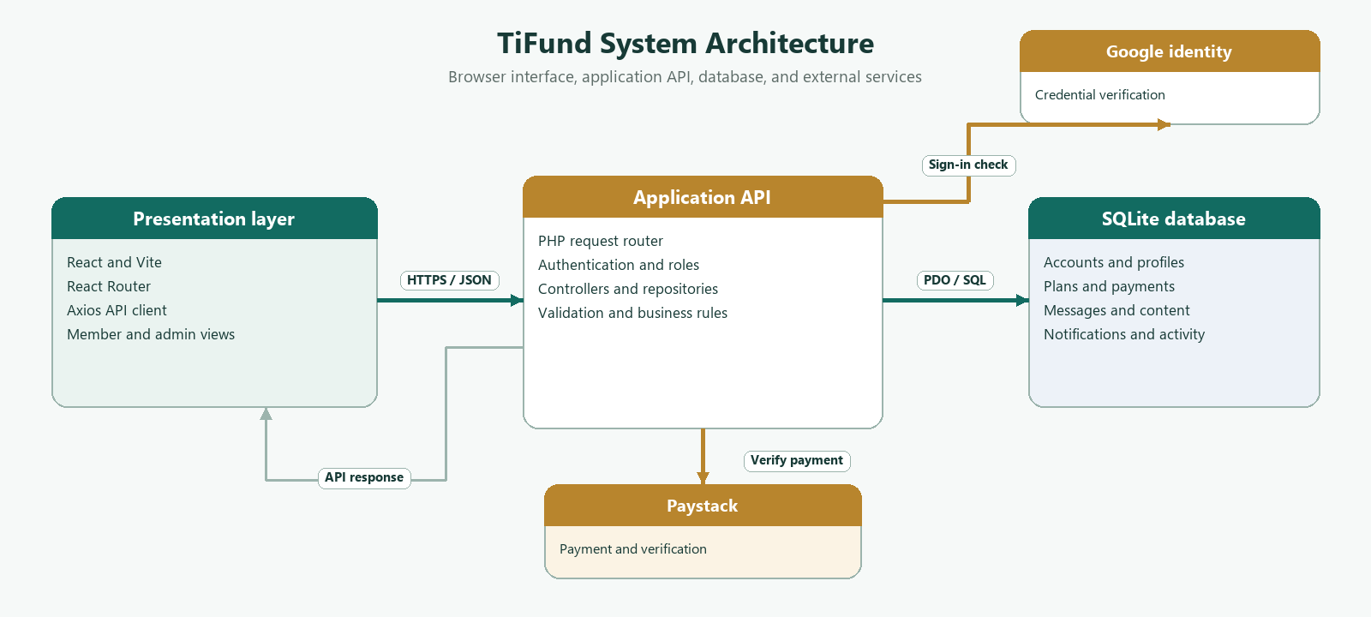
1. Browser | 2. PHP API | 3. SQLite or provider
User opens a page or submits a form. | Router identifies the public or protected route. | SQLite reads or writes records; a provider handles external work.
Axios sends JSON, bearer token, or file. | Controller validates input, permissions, and ownership. | API returns only the result permitted for that request.
Frontend displays result or error. | Response is formatted as JSON or a protected document stream. | —

3.6 User roles and access
Role | Main access
Visitor | Public home, about, services, plans, contact options, and contact form.
Teacher/member | Own dashboard, account, payment history, notifications, and own messages.
Administrator | Admin overview, member dashboard, user tools, plans, content, messages, payments, and activity.

The dashboard route chooses the admin or member dashboard using the signed-in role. The API separately checks roles for administrative routes. The configured Google account email is used by the current sign-in flow to assign administrator access. This value must be set correctly before deployment.

CHAPTER THREE

Database design and data flow

3.7 Main data entities
Entity | Key information | Purpose or relationship
users | ID, Google ID, name, email, role, status | Account identity and access role.
teacher_profiles | User ID, phone, school, staff ID, national ID, birth date, photo, verification state | One teacher profile per user.
plans | Name, amount, cadence, description, benefits, active state | Contribution choices displayed to members.
payments | User ID, plan ID, reference, amount, currency, status, dates | Payment records associated with an account.
contact_messages | User ID, sender details, subject, message, status, date | Account-linked or anonymous contact submissions.
content | Page key, content key, value, update date | Editable public website content.
notifications | User ID, title, message, read date | Notifications sent to an account.
teacher_documents | User ID, type, path, MIME type, size | Private uploaded teacher documents.
activity_logs | User, actor, action, entity, metadata, date | Administrative and account activity history.
app_settings | Setting key and value | Seed markers and application settings.

Figure 2. Database relationship diagram
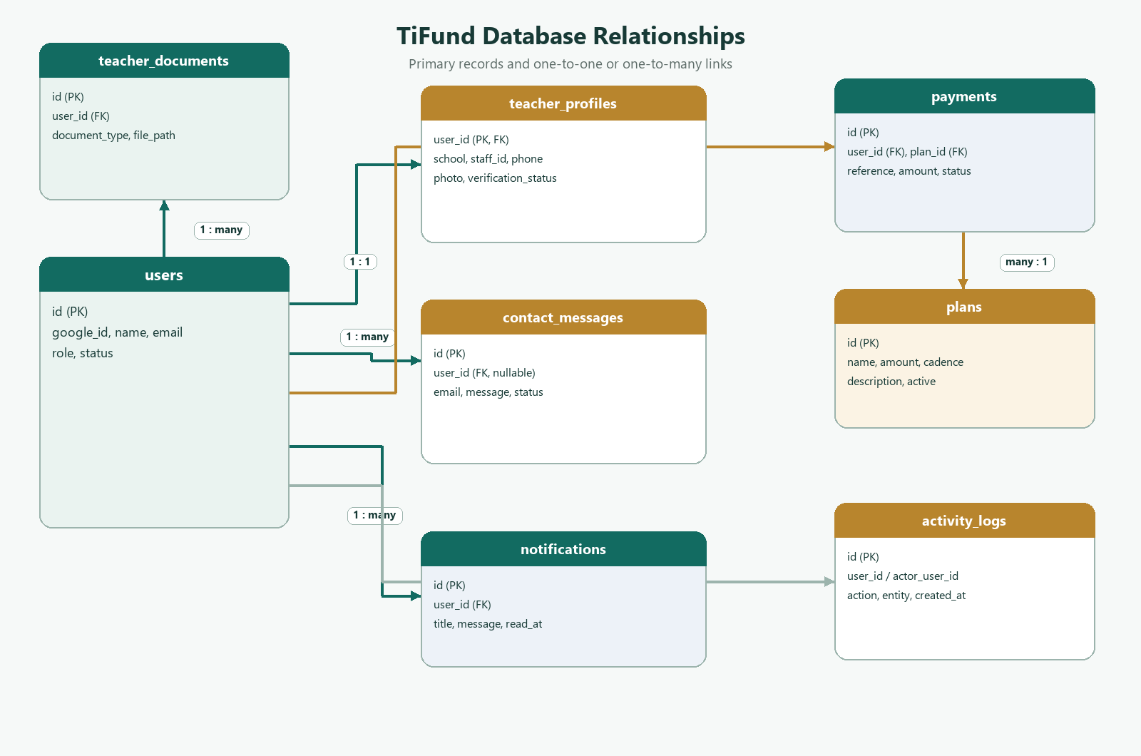
Parent record | Relationship | Related record
users.id | one to one | teacher_profiles.user_id
users.id | one to many | payments.user_id
users.id | one to many | contact_messages.user_id; nullable for visitors
users.id | one to many | notifications.user_id
users.id | one to many | teacher_documents.user_id and activity user/actor IDs
plans.id | one to many | payments.plan_id

The account is the identity record. Teacher-specific values are stored in a separate profile and joined when account data is returned. Deleting a user cascades to selected owned records; contact messages use a nullable user link so a message can remain after account deletion.

CHAPTER THREE

Process design, privacy, and validation

3.8 Contact message flow

Figure 3. Request flow: contact and payment
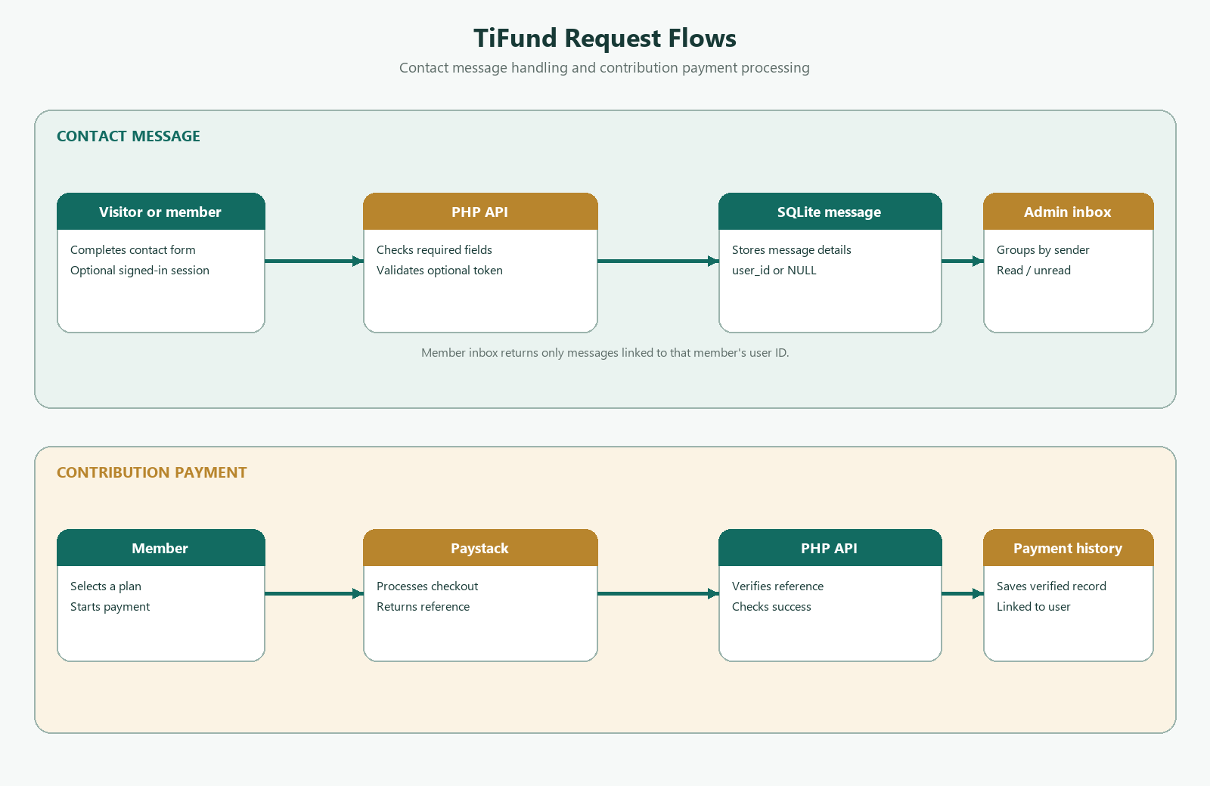
Step | System action
1 | A visitor or member completes the public contact form.
2 | The API validates the required name, email, and message fields.
3 | With a valid signed-in token, the API stores the account ID; otherwise the message remains anonymous.
4 | An administrator opens the grouped inbox and reviews a sender’s messages.
5 | The administrator marks an individual message read or unread; the unread count is updated.
6 | The member messages endpoint returns only rows linked to that member account.

3.9 Payment flow

Payment flow steps
A member chooses a contribution plan and begins payment using the frontend payment widget. The API checks the payment reference with Paystack before recording a successful payment. The API can also receive a signed Paystack webhook and update a matching reference. The payment repository associates the record with the signed-in account, and the member history query filters by that account ID.

3.10 Privacy and security controls
- Protected routes require a bearer token; administrator operations check the account role.
- Account payment and message queries are scoped to the signed-in user ID.
- SQL uses prepared statements for user-submitted values.
- Uploads are type-checked, size-limited, randomly named, and stored outside public URLs for private teacher documents.
- The API checks document ownership before returning a document to an administrator.
- The API checks whether an old upload is still referenced before deleting it.
- Environment files and secrets stay out of source control; the Paystack secret belongs only on the API server.

3.11 Ethical considerations
Teacher profile fields and uploaded documents may contain personal data. Production operation should use informed organisational procedures for collecting, viewing, retaining, and deleting that information. Access should be granted only to authorized staff. Test data should be fictional. Payment records should be used for account administration and reconciliation only. This document does not claim legal compliance certification or independent security assessment.

3.12 Validation plan
Validation combines frontend build checks, PHP syntax checks, database migration tests, API route checks, access-control tests, payment-provider sandbox tests, and user acceptance tests. Current results are reported separately so completed checks are not confused with proposed tests.

CHAPTER FOUR

System implementation

4.1 Development environment
The repository contains two application parts. The API is PHP and uses Composer-managed dependencies, PDO SQLite, cURL, and an environment file. The frontend uses React, React Router, Axios, Vite, and npm. The API starts its schema bootstrap when the SQLite connection is opened. The API README identifies local origins accepted by default and explains how to configure another frontend origin.

4.2 Main implementation modules
Module | Implementation role
Router | Matches request paths and methods; dispatches public, signed-in, and admin actions.
AuthController and UserRepository | Verify Google credentials, reuse existing accounts, create missing teacher profiles, and return linked data.
Schema and Connection | Create SQLite tables, enable foreign keys, use WAL for file databases, and apply missing-column updates.
PublicController | Serve public plans and content, save contact requests, and accept registration.
UserController and PaymentController | Manage member profiles, own messages, payment history, and notifications.
AdminController | Manage teachers, documents, content, plans, messages, payments, notifications, and activity.
React pages | Render public pages, member and admin dashboards, account pages, history, plans, and content tools.
Shared components | Provide navigation, cards, image previews, avatars, payment widget, activity list, and contact inbox.

4.3 Public pages and content
The public interface includes home, about, services, plans, contact, login, and registration pages. Home and content pages request editable data from the API. Administrators edit services, contact details, home content, carousel entries, worker information, sponsor entries, and frequently asked questions through content tools. Global CSS variables provide shared colours, card surfaces, spacing, and theme values.

4.4 Account and admin interfaces
The member dashboard presents contributions, recent activity, and a messages section. The administrator dashboard includes an overview and a separate sender-grouped messages section, plus an embedded view of the administrator’s own member dashboard. Other admin routes provide user/member management, teacher registration, payment history, activity, content, and plan management.

CHAPTER FOUR

User guide

4.5 Visitor tasks
- Open the home page and use navigation to view About, Services, Plans, or Contact.
- Use the plans page to review the available amount, cadence, description, and benefits.
- On Contact, choose configured WhatsApp, call, or email links, or use the form.
- The contact form requires a name, valid email, and message; phone and subject are optional.
- Submit the form and wait for the success confirmation.

4.6 Member tasks
- Choose Login and complete Google sign-in with an account accepted by the application.
- Open Dashboard. The system routes an administrator to administration and a teacher to the member view.
- Choose Manage account to update permitted profile fields. Google-provided name and email are read-only. Staff ID edits are restricted to administrators.
- Use Messages to view only contact submissions associated with the signed-in account.
- Open payment history to review recorded transactions. Use Notifications to view and mark a notification read.
- If plan payment is offered, select the plan and follow the payment widget. The API verifies payment before saving success.

4.7 Administrator tasks
- Sign in using the Google account configured for administrator access.
- Use administration navigation to open Users, Register teacher, Payments, Activity, Content, or Plans.
- Open Messages on the dashboard and expand a sender group to view individual messages.
- Use Mark as read or Mark unread on an individual message. The unread indicator and dashboard count reflect the saved status.
- Use Content to update public services, contact details, carousel, worker, sponsor, and FAQ information.
- Use member tools to review teacher data and documents. Private documents are delivered through the authenticated admin route.

4.8 Images and uploads
Profile images use a default avatar when no image is stored. The frontend resolves managed API image paths against the configured API address. Uploads are limited by file type and size. Profile photos accept JPEG, PNG, and WebP up to 5 MB. Teacher documents accept PDF, JPEG, and PNG up to 10 MB. When replacing a stored file, the API checks for other database references before deleting the old file.

CHAPTER FOUR

Installation and API reference

4.9 Local setup
Part | Commands and configuration
API requirements | Install PHP with pdo_sqlite and cURL, then run composer install in api.
Start API | From api: php -S 127.0.0.1:8000 -t .
API environment | Set DB_PATH if needed; configure API_SECRET, GOOGLE_CLIENT_ID, GOOGLE_ACCOUNT, PAYSTACK_SECRET_KEY, and FRONTEND_URL or FRONTEND_URLS in api/.env.
Frontend setup | From frontend: npm install, then npm run dev.
Frontend environment | Set VITE_API_URL, VITE_GOOGLE_CLIENT_ID, and VITE_PAYSTACK_KEY in frontend/.env. Use only a public payment key in the frontend.
Database | The default file is api/database/tifund.sqlite. The API initializes schema and default content automatically.

The configuration names above are based on current project source and README files. Keep environment files private. Replace local development secrets with strong production values and use HTTPS for deployed API and frontend traffic. A new SQLite database does not automatically import MySQL records.

4.10 Main API routes
Access | Routes and purpose
Public | POST /auth/google; GET /plans; GET /content/home; GET /content/services; GET /content/contact; POST /registration; POST /contact; POST /payments/webhook.
Signed-in | GET/PUT /account; GET /account/messages; GET /history; GET /notifications; PUT /notifications/{id}/read; POST /payments/verify.
Administrator | GET /admin/summary, /admin/users, /admin/teachers, /admin/messages; PUT /admin/messages/{id}/status; teacher and document routes; content, plans, notifications, payment, and activity routes.

4.11 Operational notes
- Keep backups of the SQLite database outside the source tree and test restoration.
- Check PHP and frontend logs when a request fails; do not expose secrets in logs or screenshots.
- Confirm Google client, configured administrator email, Paystack keys, API origin, CORS origin, and HTTPS settings before deployment.
- Use a Paystack test environment for end-to-end payment checks before any live transaction.
- Review the API and frontend README files for current setup instructions.

CHAPTER FOUR

Testing and results

4.12 Validation results
The checks below were run against the current project changes and are limited to build, syntax, migration, and workspace integrity. They confirm that the application can be built and that selected API/database changes parse and run. They are not a complete security review, payment certification, or user acceptance study.
Check | Method | Result
Frontend production build | npm run build in frontend | Passed. Vite created production assets. It reported that the minified JavaScript chunk exceeds the 500 kB advisory threshold.
PHP syntax | php -l on changed API files | Passed for schema, router, public, user, and admin controller files.
SQLite message migration | In-memory SQLite smoke test | Passed. Matching legacy messages linked once; later anonymous submissions remained unlinked.
Diff whitespace | git diff --check | Passed with no whitespace errors.
Browser and user acceptance | Not run as part of recorded checks | Pending. Test with representative teacher and administrator accounts.

4.13 Recommended functional test cases
ID | Test case | Expected result
T-01 | Sign in with an existing Google account. | Existing account is reused and returned with its teacher profile.
T-02 | Open an admin route as a teacher. | The API denies the request and admin pages remain protected.
T-03 | Submit contact form while signed in. | Message is linked to the account and appears in that member inbox.
T-04 | Submit a contact form anonymously. | Message appears to administrators and not in any user's inbox.
T-05 | Change contact message status. | Only an administrator can save read or unread state.
T-06 | Replace an image used by another record. | A still-referenced file is retained.
T-07 | Verify payment with Paystack test credentials. | Only provider-confirmed payment is recorded as successful.
T-08 | Update an allowed teacher profile field. | The change persists and account data remains linked to the profile.

4.14 Evaluation
The current validation supports the conclusion that the changed frontend builds, selected PHP files are syntactically valid, and the message ownership migration behaves as expected in the tested SQLite case. The functional cases above should be executed in staging. Provider integration, role boundaries, file replacement, and accessibility should be assessed before deployment.

CHAPTER FIVE

Discussion and conclusion

5.1 Summary of the work
TiFund combines public fund information with authenticated member and administration functions. The architecture joins React pages, a PHP API, and SQLite records. Google-based sign-in identifies users; the API reuses existing accounts and keeps each user linked to a teacher profile. Members can review plans, account information, payment history, notifications, and their own contact messages. Administrators have tools for managing teacher records, plans, content, payments, activity, notifications, and grouped messages.

5.2 Interpretation of results
The successful frontend build and API syntax checks show that the reviewed code can be compiled and parsed. The SQLite smoke test shows that the new message ownership field can associate legacy messages by email during a one-time migration while leaving future anonymous messages unlinked. These results demonstrate selected technical behaviour, not the overall quality of live service or member satisfaction.

5.3 Strengths
- Single role-aware dashboard routing for teachers and administrators.
- Account and teacher profile details are returned together and returning sign-ins reuse records.
- Administration includes editable plans and public content as well as account management.
- Contact submissions have account ownership when submitted by signed-in users and are separated from anonymous submissions.
- Shared theme variables, reusable components, managed image URLs, and guarded upload cleanup support maintenance.

5.4 Limitations and challenges
- There is no automatic MySQL-to-SQLite data migration.
- The application needs end-to-end testing with real browser sessions and provider sandbox accounts.
- The production frontend build reports a large JavaScript chunk warning.
- The API currently disables TLS peer verification for Google token information requests for local development; production should enable certificate verification.
- The API secret has a local development fallback; production must set a strong private value.
- This documentation does not establish investment performance, financial outcomes, legal compliance, or independent security certification.

CHAPTER FIVE

Recommendations and conclusion

5.5 Recommendations
Priority | Recommended work | Reason
Before production | Enable TLS verification for Google token validation and replace all local fallback secrets. | Protect credential checks and authenticated API access.
Before production | Run integration tests for sign-in, roles, profiles, messages, uploads, and Paystack test transactions. | Confirm full user flows, not only build and syntax.
Before migration | Design and test a controlled MySQL export/import process with backups and reconciliation. | Protect existing member and transaction records.
Operational | Set up automated SQLite backups, restore drills, monitoring, and error reporting. | Reduce data-loss and service-interruption risk.
Usability | Conduct acceptance sessions with teachers and administrators; record accessibility findings. | Check navigation, forms, and messages with real users.
Performance | Review code splitting and bundle composition to reduce the large JavaScript chunk. | Improve page loading on slower devices and connections.
Governance | Set retention rules and access procedures for documents, payments, and contact messages. | Support responsible handling of personal information.

5.6 Future work
Further development may include verified member statements, audited plan changes, richer message assignment and response tracking, exportable administrative reports, database migration tooling, improved accessibility testing, and automated API integration tests. These features should be selected with the fund’s operational stakeholders and implemented with clear privacy, financial, and retention requirements.

5.7 Conclusion
TiFund provides a practical software foundation for teacher accounts, contribution records, services, contact requests, and administrative oversight. It uses a role-aware interface and a relational data model to bring related records together. The completed build and migration checks provide useful evidence for the current implementation, while broader integration, user, payment, and deployment testing remain essential. With production security configuration, tested data migration, reliable backup processes, and stakeholder evaluation, the project can be prepared for controlled operational use.

REFERENCES

References and supporting information
[1] Kumasi Technical University, Department of Computer Science. (n.d.). Project development format and assessment: BCT 400 Project II [Course handout, four pages]. User-supplied PDF, Project development format and assessment.pdf.
[2] Manu Anthony. (2025). Automated e-learning system with SMS alerts, quiz features, and assignment monitoring [Project report]. Kumasi Technical University, Faculty of Applied Sciences and Technology, Computer Science Department. User-supplied Word example, SCOTT- COMBINED (1-5).docx.
[3] TiFund project repository. (2026). README.md, api/README.md, frontend/README.md, PHP API source, React frontend source, and SQLite schema. Project files reviewed for this documentation, October 2026.

Appendix A. Documentation basis
The document order follows the course handout’s preliminary section and five-chapter guidance [1]. The title page and formal report presentation are informed by the supplied example report [2]. Descriptions of TiFund functions, implementation, API routes, and validation status are based on the current project files and recorded checks [3]. The supplied report is cited as a formatting example only; its e-learning content is not reused as TiFund research.

Appendix B. Core files
File or folder | Purpose
README.md | Project overview and local startup instructions.
api/src/Router.php | API request routing.
api/src/Database/Schema.php | Executable SQLite schema setup and migrations.
api/src/Controllers/ | Public, user, payment, authentication, and admin actions.
api/src/Repositories/ | Database access for accounts, payments, and content.
api/database/schema.sql | Reference SQLite schema.
frontend/src/App.jsx | Frontend routes and role-aware dashboard selection.
frontend/src/pages/ | Public, account, member, and admin pages.
frontend/src/components/ | Reusable interface components.
frontend/src/style.css | Global theme variables and component styles.

Appendix C. Project care checklist
- Keep API and frontend environment files private.
- Back up the SQLite database and test restoring it.
- Use fictional data for testing.
- Verify teacher and administrator permissions before release.
- Test payments using provider test mode before live transactions.
- Review content and plan values with authorized fund staff.

